**Suicide Prevention Pack**

**Organisations and communities**

“Talking about suicide saves lives”

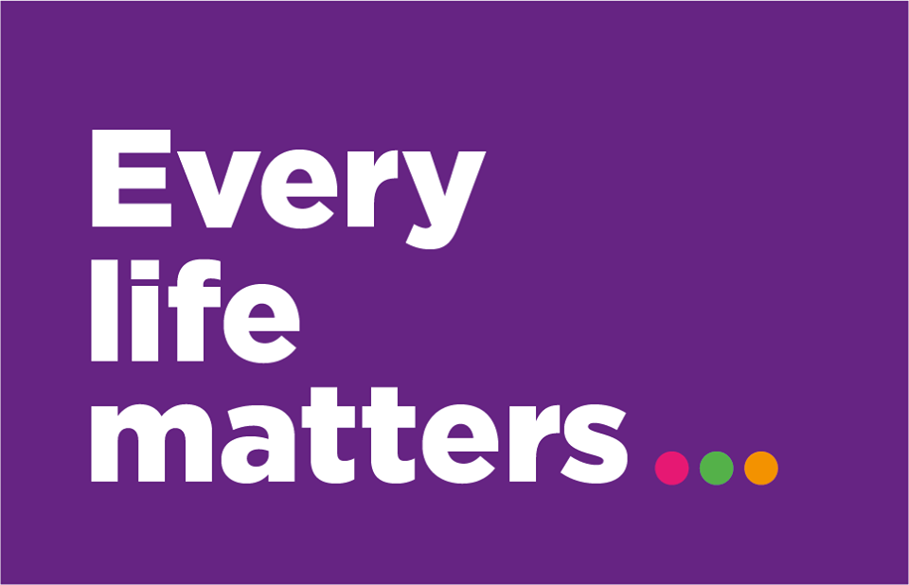





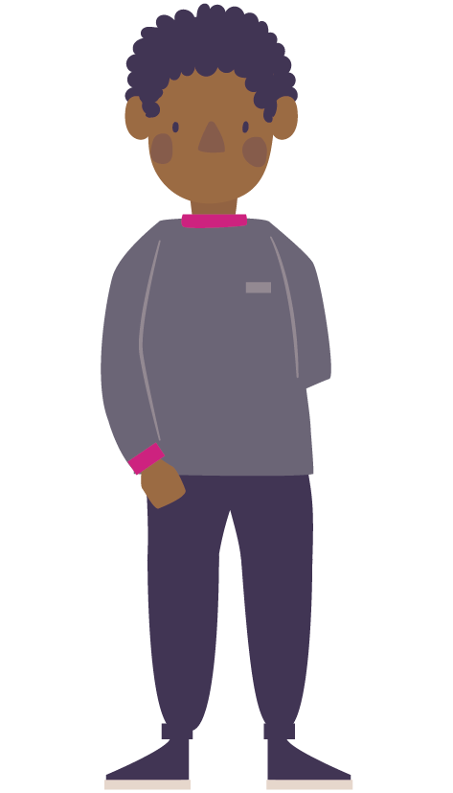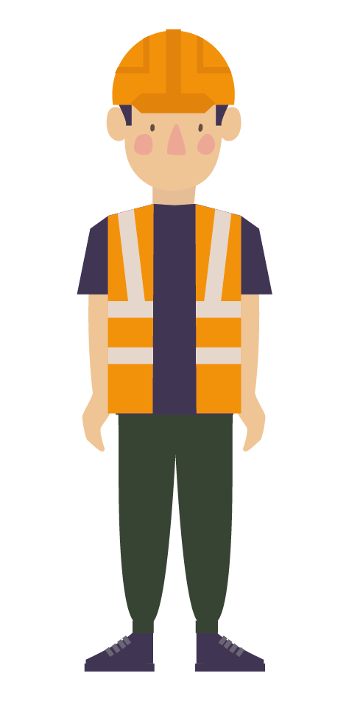

**About this pack**

Thank you for taking the time to read this pack. As a suicide prevention charity, we come from the perspective that suicide is everyone's business, and we truly value your support in helping raise awareness of the subject within your community.

Across Cumbria, we sadly lose one life to suicide every 6 days within our county, with our rates of suicide being higher than the national average.

The focus of this pack is to provide resources for your organisation to share amongst your local community and help build awareness. This includes social media graphics, posters and ways to get involved.

Alongside this, we have included some materials for World Suicide Prevention Day, taking place on the 10th of September, a chance to come together with others worldwide to light a candle for those lives lost and those who continue to live with these thoughts.

We hope the information within the pack will provide you with plenty of information to help raise awareness and further conversations about suicide.

Should you require any more resources or information please contact [sarah.cameron@every-life-matters.org.uk](mailto:sarah.cameron@every-life-matters.org.uk).

Thank you again for your support.

Sincerely,

*Sarah Cameron*

Sarah Cameron

Suicide safer community coordinator, West Cumbria

**Contents**

1. Suicide Prevention Social Media
2. Creating your own Social media
3. Ways to get involved
4. World Suicide Prevention Day
5. Training opportunities
6. Suicide in Cumbria
7. Every Life Matters
8. Contact us

**1. Suicide Prevention Social Media**

Below are a series of graphics and pre-written content to help raise awareness of suicide prevention. Right-click on graphics to download to your desktop via “save picture as” option. Or you can download from our website [www.every-life-matters.org.uk/wspd](http://www.every-life-matters.org.uk/wspd).

We kindly ask that you tag us in any content that goes out, our social media links are included below for ease:

Facebook - @everylifematters

Twitter - @Every_Life_Cumb

Instagram - @Everylifecumbria

Please note: although these posts are numbered you may wish to post them in any order you see fit, we would ask that any changes to key messages are minimal to ensure that messaging stays consistent and clear.

**Graphics 1** please feel free to choose which graphic to use

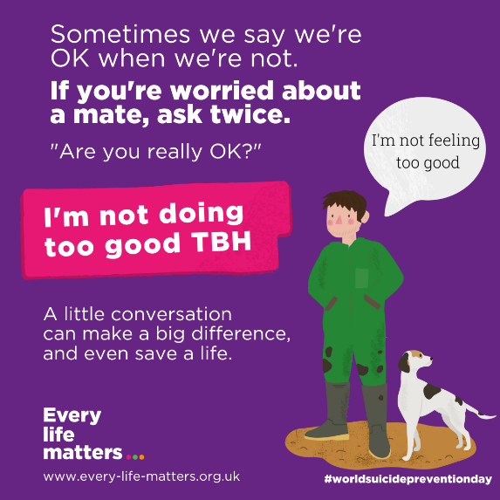 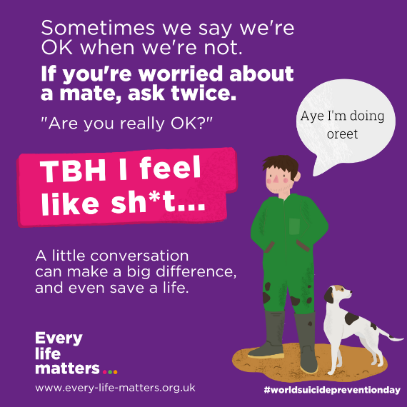

**Facebook:**

Sometimes we say we are “OK” when we’re not. If you are worried about a mate don’t take “OK” for an answer. Tell them you are concerned about them and ask again, “Are you really OK?”. A little conversation can make a big difference, and maybe even save a life. For ideas on how to start the conversation visit [Helping Others - Every Life Matters (every-life-matters.org.uk)](https://www.every-life-matters.org.uk/helping-others/)

**Instagram:**

Sometimes we say we are “OK” when we’re not. If you are worried about a mate don’t take “OK” for an answer. Tell them you are concerned about them and ask again, “Are you really OK?”. A little conversation can make a big difference, and maybe even save a life. For ideas on how to start the conversation visit [Helping Others - Every Life Matters (every-life-matters.org.uk)](https://www.every-life-matters.org.uk/helping-others/)

**Twitter:**

If you're worried about a mate, then take time to check in, the conversation that follows could be life saving.

To find out how to support a friend struggling with their mental health visit [http://ow.ly/1TMR50HcILU](http://ow.ly/1TMR50HcILU?fbclid=IwAR1AgcNlhMdsc8QMVgMUMUJzgA9aihIfM7WrZChdeGzY5xDMuH1Dm205BOI)

**Graphics 2**

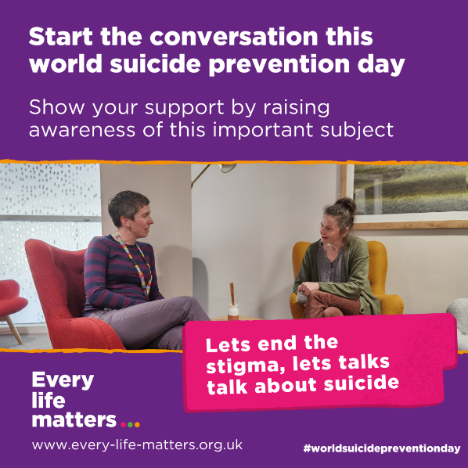

**Facebook:**

This World Suicide Prevention Day show your support by talking about suicide. Stigmas associated with suicide can prevent someone reaching out for help, leaving them feeling alone and isolated. By being comfortable talking about suicide within your workplace, communities or with friends and family, you will be helping to end stigma and letting people know you care.

Discover more ways you can help by visiting <https://www.every-life-matters.org.uk/helping-others/>

Talking about suicide saves lives.

#WSPD #EndTheStigma

**Instagram:**

This World Suicide Prevention Day show your support by talking about suicide. Stigmas associated with suicide can prevent someone reaching out for help, leaving them feeling alone and isolated. By being comfortable talking about suicide within your workplace, communities or with friends and family, you will be helping to end stigma and letting people know you care.

Discover more ways you can help by visiting <https://www.every-life-matters.org.uk/helping-others/>

Talking about suicide saves lives.

#WSPD#EndTheStigma

**Twitter:**

This World Suicide Prevention Day show your support by talking about suicide and help end stigma.

Discover more ways you can help by visiting https://www.every-life-matters.org.uk/helping-others/

Talking about suicide saves lives.

#WSPD #EndTheStigma

**Graphics 3** please feel free to choose which graphic to use

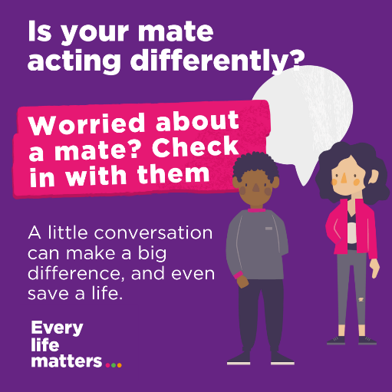 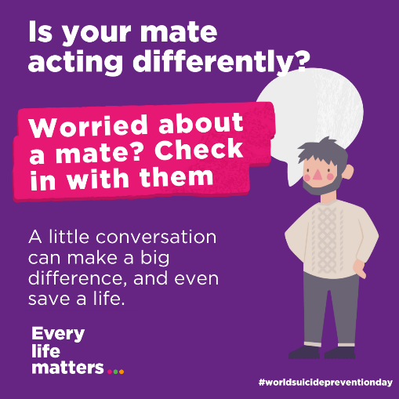

**Facebook:**

Many people find it difficult to reach out for support. If someone is acting differently – like not seeing friends, losing interest in things, drinking more or having mood swings – it might be a sign they are struggling to cope with challenges in their life.

The smallest displays of kindness, like picking up the phone to check-in on someone, and the conversation that follows, could make all the difference. And perhaps even save a life.

To find out more about the signs some might be experiencing mental health problems visit [every-life-matters.org.uk](http://every-life-matters.org.uk/?fbclid=IwAR0dNc8OxX-f_wZbtuhP8F4z0pPhjl158BINUNB7QJYl1MZHtJFZsh7gIQM)

**Instagram:**

Many people find it difficult to reach out for support. If someone is acting differently – like not seeing friends, losing interest in things, drinking more or having mood swings – it might be a sign they are struggling to cope with challenges in their life.

The smallest displays of kindness, like picking up the phone to check-in on someone, and the conversation that follows, could make all the difference. And perhaps even save a life.

To find out more about the signs some might be experiencing mental health problems visit the Every Life Matters website.

**Twitter:**

Are you noticing a mate acting differently? The smallest displays of kindness, like picking up the phone to check-in on someone could make all the difference, and perhaps even save a life.

Find out more about how to support someone by visiting www.every-life-matters.org.uk

**Graphics 4** please feel free to choose which graphic to use

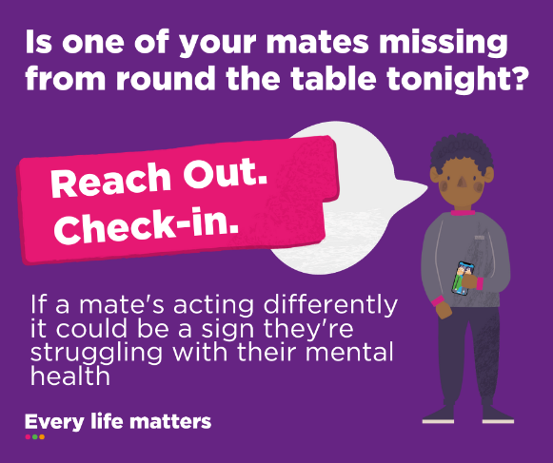 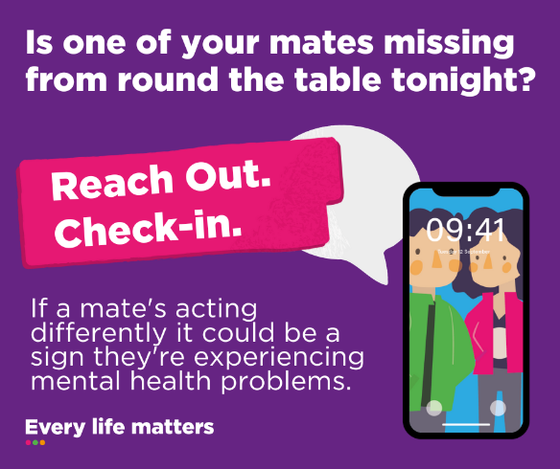

**Facebook**

Is one of your mates missing from round the table tonight? If a mate is acting differently, it could be a sign they’re experiencing mental health problems.

Many people find it difficult to reach out for support and sometimes we might need to ask, and ask again, “How are you?” If you are worried about someone don’t be content with an “I’m alright mate”.

Be helpfully nosey, and be patient. Let them know why are concerned, and that you are there for them.

For more ideas <https://www.every-life-matters.org.uk/helping-others/>

**Instagram**

Is one of your mates missing from round the table tonight? If a mate is acting differently, it could be a sign they’re experiencing mental health problems.

Many people find it difficult to reach out for support and sometimes we might need to ask, and ask again, “How are you?” If you are worried about someone don’t be content with an “I’m alright mate”.

Be helpfully nosey, and be patient. Let them know why are concerned, and that you are there for them.

For more ideas visit the Every Life Matters website.

**Twitter**

Many people find it difficult to reach out for support. If you are worried about someone don’t be content with an “I’m alright mate”.

Be helpfully nosey, and be patient. Let them know you are there for them. Find out more <https://www.every-life-matters.org.uk/helping-others/>

**Graphics 5**

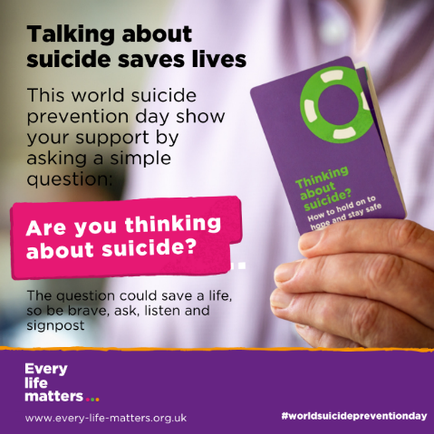

**Facebook:**

It’s OK to talk about suicide. 1 in 5 people will think about suicide in a lifetime, normalising conversations can reduce the stigma and encourage more people to get the help they need. Just because someone is having thoughts of suicide does not make it inevitable.

Talking about suicide openly and directly will not put the idea in someone's head. The real risk is not mentioning it at all. If you are worried about someone ask directly "Are you thinking about suicide?" This reduces uncertainty and lets them know you care and you are there to help.

<https://www.every-life-matters.org.uk/helping-others/>

**Instagram:**

It’s OK to talk about suicide. 1 in 5 people will think about suicide in a lifetime, normalising conversations can reduce the stigma and encourage more people to get the help they need. Just because someone is having thoughts of suicide does not make it inevitable.

Talking about suicide openly and directly will not put the idea in someone's head. The real risk is not mentioning it at all. If you are worried about someone ask directly "Are you thinking about suicide?" This reduces uncertainty and lets them know you care and you are there to help.

**Twitter:**

It’s OK to talk about suicide. 1 in 5 people will think about suicide in a lifetime, normalising conversations can reduce the stigma and encourage more people to get the help they need. Just because someone is having thoughts of suicide does not make it inevitable.

**Posters**

Download posters [here](http://www.every-life-matters.org.uk/wspd/) to print and display at your organisation/ in your community.

**2. Creating your own Social Media content**

**Sharing Lived Experiences**

Your story matters and can be a powerful tool for change. Sharing your stories of hope and recovery has the power to help others through a crisis and to dispel stigma and myths about suicide. Hearing other people’s real-life experiences can be one of the most important and effective ways of changing attitudes and offering hope. For further advice and support in finding the right words to convey your message then feel free to email [info@every-life-matters.org.uk](mailto:info@every-life-matters.org.uk).

**Ways of using lived experience**

* Video- this could include talking heads shots, video that doesn’t identify you but uses your voice, or a video that uses others to share your words.
* Written stories- for instance using your words to illustrate social media posts.

**Reach out for support**

If you want to share your experiences and would like support please get in contact or check out our website for resources and our support directory. Use the *Sharing your Story* handbook for more guidance <https://www.every-life-matters.org.uk/wp-content/uploads/2023/02/LE-Toolkit-v3.pdf>

**Storytelling guidelines**

* Remember that your story is your own. Only share what you are comfortable sharing and what you are okay with people knowing.
* Ask yourself if you are ready to speak.
* Prepare the key messages you want to share, write them down beforehand if this helps.

**Safe and Positive Messaging** **Guidelines**

Suicide is an issue of community concern and in general, having a conversation with someone does not increase suicidal behaviour. However, this is not the same with one-way mass communication like public speaking or in the media. The evidence clearly tells us that we need to proceed with caution due to the potential risk of causing unintended harm to those in the community who are vulnerable to suicide.

**What language should I use?**

Certain ways of talking about suicide can alienate members of the community, sensationalise the issue or inadvertently contribute to suicide being presented as glamorous or an option for dealing with problems. People who are vulnerable to suicide, or bereaved by suicide, can be particularly impacted by language. References to suicide should not be used out of context (such as ‘career suicide’) as it may cause offence. It is important to use language that is in line with suggestions for the media (outlined below).

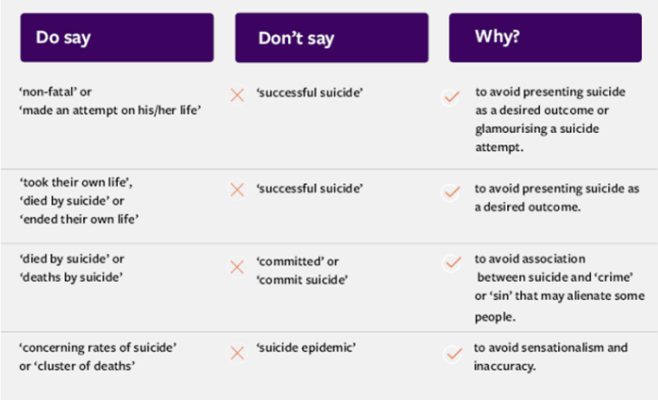

**Scripts**

Below are scripts that can be read out by members of your team to share some of the key messages Every Life Matters promote. Feel free to choose which script(s) you want to film. Share these on your social media platforms or with Every Life Matters to share on our platforms. Email your videos to [sarah.cameron@every-life-matters.org.uk](mailto:sarah.cameron@every-life-matters.org.uk).

**At the beginning of each script why not introduce yourself, say something about yourself, like where you work, how people will know you, and only if you feel comfortable, why you support suicide prevention.**

**Script 1-Talking about suicide saves lives**

Thoughts of suicide affect more people than we think, and are a common response to challenging life events such as debt or employment issues, long term physical health problems, relationship breakdowns or bereavement. 1 in 5 people will have thoughts of suicide during their lifetime. And 1 in 17 people will have thoughts of suicide each year.

But just because someone is having thoughts of suicide it does not mean it's inevitable they will end their life. But it does mean they may need to talk about the way they are feeling, and may need more help and support.

So if you know someone who is struggling and you are at all concerned someone you know may be thinking of ending their own life don’t be afraid to ask, and ask directly, “are you thinking about suicide?”

It won’t put the idea in their head and the conversation that follows could be a lifesaver.

Let's end the stigma, lets talk about suicide

**Script 2- Trust your Gut instinct**

Many people with thoughts of suicide do not let their friends and family know directly how they are feeling – but often there are warning signs that someone may be thinking about suicide – signs we can be alert to.

People might be talking about feeling hopeless, out of control, trapped, that people would be better off without them. They might withdraw from friends and family, lose interest in life, their appearance or work.

They might begin to self-harm more or do other risky behaviour. They may be researching suicide methods on-line.

Sometimes people become suddenly calm after a period of being down, give away possessions or put their affairs in order.

And this might be happening alongside stressful life events, such as money, work or housing problems, relationship breakdowns, or long term mental or physical health problems they are struggling to manage.

Like a jigsaw. Piece together what you see and hear.

Trust your gut instincts.

If you are at all concerned someone you know may be thinking of ending their own life don’t be afraid to ask, and ask directly, “are you thinking about suicide?”

It won’t put the idea in their head and the conversation that follows could be a lifesaver.

Let's end the stigma, lets talk about suicide

**Script 3-Check-in**

We can all play a role in helping people who are struggling with their mental health, or are having thoughts of suicide.

If you are worried someone you know might be struggling to cope don’t be content with an “I’m alright mate”. Sometimes we might need to ask - and then ask again, “How are you, really?” Be helpfully nosey, and be patient. Let them know why you are concerned, and that you are there for them.

The smallest displays of kindness, like picking up the phone to check-in on someone, and the conversation that follows, could make all the difference. You don’t need to solve their problems and knowing someone cares could be enough to get them through.

And trust your gut instincts.

If you are at all concerned someone you know may be thinking of ending their own life don’t be afraid to ask, and ask directly, “are you thinking about suicide?”

It won’t put the idea into their head and the asking the question could be a lifesaver.

Let's end the stigma, let’s talk about suicide

**Script 4- Life Events**

Thoughts of suicide, or of wanting to die, are a common response to challenging life events. 1 in 8 people with problem debt for example will have thought about suicide.

But talking about suicide with someone who is really struggling with debt or other challenges can feel like a nerve wracking thing to do.

We might find ourselves tiptoeing around the subject because we’re scared of saying the wrong thing, or worried we might offend the person. Or worse still, that we might put the idea into their head.

But if someone is having thoughts of suicide they may be feeling cut off from people around them, frightened or ashamed about wanting to die, or desperate for help but afraid to ask.

They may need YOU to start the conversation for them – to show they have permission to talk – and that they don’t have to be alone with these dark and overwhelming thoughts.

Trust your gut instincts.

If you are at all concerned someone you know may be thinking of ending their own life don’t be afraid to ask, and ask directly, “are you thinking about suicide?”

It won’t put the idea into their head and the conversation that follows could be a lifesaver.

Let's end the stigma, let’s talk about suicide

**3. Ways to get involved**

**Creating Hope Through Action**

“There are simple ways we can all contribute towards marking our community’s suicide safer.’

**Light a candle on World Suicide Prevention Day**

Lighting a candle is an act of acknowledgement for support for suicide prevention, to remember loved ones who have died, and for the survivors of suicide. All around the world people light a candle at 8 pm on the 10th September.

Share an image of the candle on your social media with the #WSPD hashtag.

**Check-in**

If you are worried about someone don’t be content with an “I’m alright mate”. **Be helpfully nosey, and be patient.**Let them know why are concerned, and that you are there for them. The smallest displays of kindness, like picking up the phone to check-in on someone, and the conversation that follows, could make the difference. **And perhaps even save a life.**Find out more about how to [**support others**](https://www.every-life-matters.org.uk/helping-others/)**.**

Five simple steps to helping each other;

**Be Aware:** show interest in the people around you. Watch for the warning signs that someone might be struggling.

**Ask:** Show you care by asking questions about how someone is feeling. Trust your instincts and ask the person directly how they are doing. Ask twice. If you feel they may be struggling let them know you are worried about them and that you care.

**Listen:** Give them time and space to talk and be helpfully nosey.

**Build Support:** explore with them what support is out there. Visit <https://www.every-life-matters.org.uk/get-help/> to find resources.

**Check-in:** Keep checking in and letting the person know you are there for them.

**Fundraise or make a donation to Every Life Matters**

Every Life Matters and other suicide prevention charities rely on public donations and community fundraising to keep our work going. Send us a donation or start an event through our [**Just Giving**](https://www.justgiving.com/every-life-matters) pages.

If you are planning on fundraising for Every Life Matters please get in contact, we can provide resources to assist with this. Email us on [Info@every-life-matters.org.uk](mailto:Info@every-life-matters.org.uk).

You can also donate to Every Life Matters via our Just Giving page <https://www.justgiving.com/every-life-matters>.

**Share resources**

Sharing our resources is a simple effective way of raising awareness about suicide in your community.

**Posters:** You can download, print and display our posters in public areas- find these [here](http://www.every-life-matters.org.uk/wspd/).

**Resource Tins:** Having access to the right information, at the right time, can make all the difference in getting individuals the help and support they need. We provide free Suicide Prevention resource tins that include at-hand information to offer someone experiencing thoughts of suicide, or who is self-harming, as well as where to get help and support. You can order your free tin via our website <https://www.every-life-matters.org.uk/tins/>.

**Social Media:** Let us spread content about positive suicide prevention messages across social media. Follow us on [**Facebook**](https://www.facebook.com/EveryLifeCumbria/), [**Instagram**](https://www.instagram.com/everylifecumbria/) and [**Twitter**](https://twitter.com/Every_Life_Cumb) and share our posts to increase our reach and awareness.

**Attend Every Life Matters Training**

Signing up to attend training is a great action to take for this year’s World Suicide Prevention Day. Understand more about suicide, how to know when someone may be having thoughts of suicide, how to talk directly and comfortably about suicide, and what we can all do to offer practical support.

Every Life Matters provides free suicide prevention training for those living and working within Cumbria. More information can be found in section 5. Training Opportunities.

**Pledges**

Visit our pledge page to find some simple actions you can take today to start action against suicide in your community. <https://www.every-life-matters.org.uk/pledge/>

**4. World Suicide Prevention Day**

**About World Suicide Prevention Day**

“Our actions, no matter how big or small, may provide hope to those who are struggling.”

World Suicide Prevention Day is an annual reminder that there is an alternative to suicide, and it aims to inspire confidence and light in all of us. This year World Suicide Prevention Day is **Sunday 10th September 2023.**

Join us at **Barrow Town Hall | Carlisle Cathedral | The Bird Cage Kendal | Maryport Memorial Gardens | Cornmarket Bandstand Penrith | St Nicholas Whitehaven** to light a candle at 8 pm on the 10th of September, as the world comes together to remember those lost to suicide, and those living with thoughts of suicide [www.every-life-matters.org.uk/wspd/](http://www.every-life-matters.org.uk/wspd/),

The candle-lighting events across Cumbria are an opportunity to come together in solidarity with others who have lost family members, friends, colleagues and others to suicide, and those who want to show their support for people in our communities who are living with thoughts of suicide.

These are simple and informal events. There is no need to book, there will be no speeches, ceremony or pressure to speak to others. Candles will be available if you can’t bring your own, and pictures of a lost loved one and/or messages of support are also welcomed. People are encouraged to turn up anytime from 7:30pm onwards to light a candle, ready to share a minute of silence and reflection at 8:00pm.

Events are based outside, but if it is raining or excessively windy we will move inside or under shelter at each venue.

We know that for some coming to such an event can be very daunting. Members of Every Life Matters will be on hand to welcome you, to talk to if you need, and to inform you about support available for those bereaved by suicide and those who are struggling with thoughts of suicide.

Find out more World Suicide Prevention day- <https://www.iasp.info/wspd/>

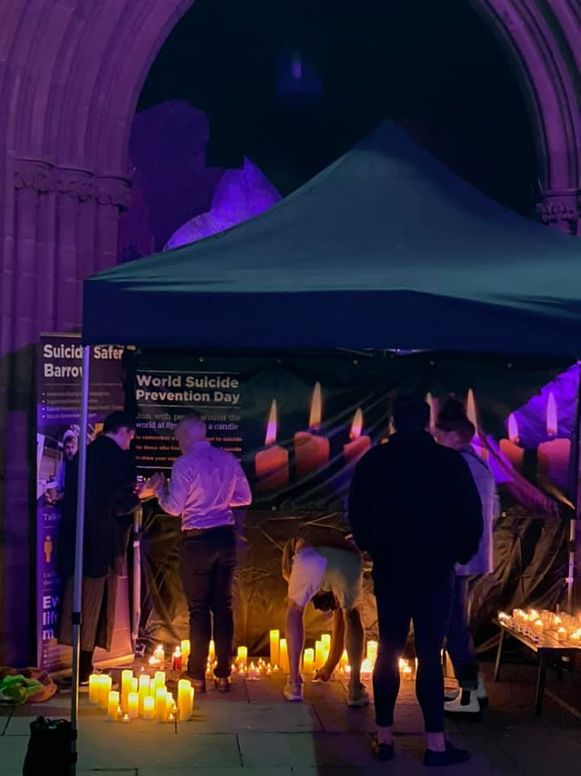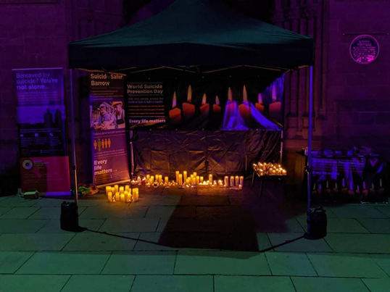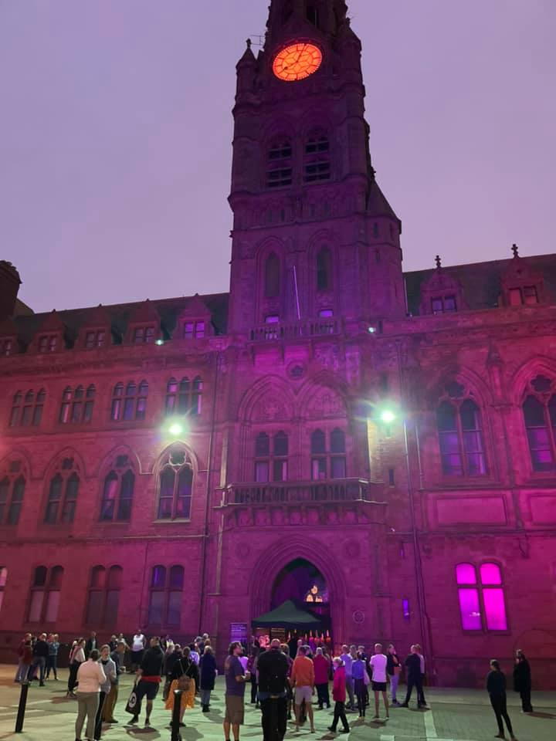

**Supporting World Suicide Prevention Day**

“Help spread the word about our 2023 events”

**Posters**

Download our World Suicide Prevention Day poster [here](http://www.every-life-matters.org.uk/wspd/). This can be printed and shared amongst staff and within public spaces as well as uploading it to your websites.

**Social Media**

Below are a series of graphics and pre-written content to help raise awareness of World Suicide Prevention Day. The following content is related to the candle-lighting events taking place on the 10th of September happening across Cumbria.

There is a generic post that anyone can use and then more location-specific graphics. Feel free to tag in the locations if they are on social media

We kindly ask that you tag us in any content that goes out, our social media links are included below for ease:

Facebook - @every life matters

Twitter - @Every_Life_Cumb

Instagram - @Everylifecumbria

Please note: we would ask that any changes to key messages are minimal to ensure that messaging stays consistent and clear.

**Generic post** please feel free to choose which graphic to use

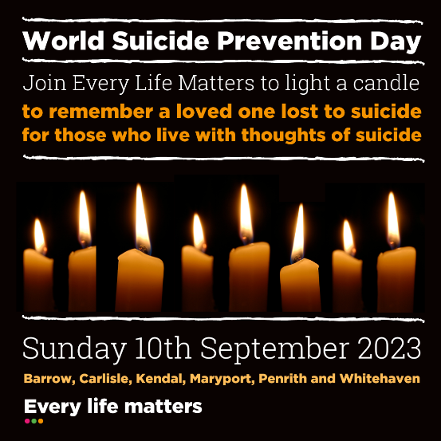 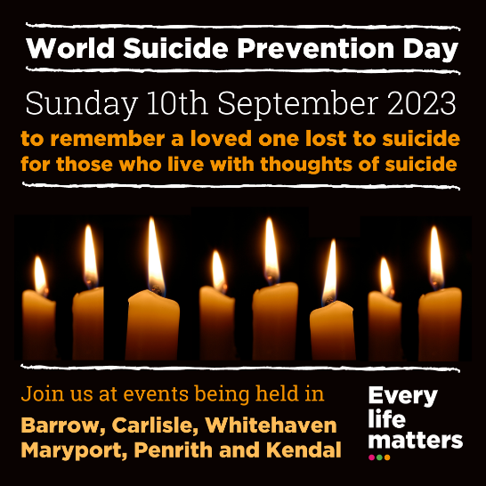

**Facebook:**

Join Every Life Matters Sunday 10th September for World Suicide Prevention Day.

Events are taking place across the county and all are welcome to join and light a candle at 8 pm in memory of those lost to suicide and for those who live with thoughts of suicide.

World Suicide Prevention Day is an annual reminder that there is an alternative to suicide and aims to inspire confidence and light in all of us; that our actions, no matter how big or small, may provide hope to those who are struggling.

To find out more about the events visit [www.every-life-matters.org.uk/wspd](http://www.every-life-matters.org.uk/wspd) #WSPD

**Instagram:**

Join Every Life Matters Sunday 10th September for World Suicide Prevention Day.

Events are taking place across the county and all are welcome to join and light a candle at 8 pm in memory of those lost to suicide and for those who live with thoughts of suicide.

World Suicide Prevention Day is an annual reminder that there is an alternative to suicide and aims to inspire confidence and light in all of us; that our actions, no matter how big or small, may provide hope to those who are struggling.

To find out more about the events visit the Every Life Matters website. #WSPD

**Twitter:**

Join Every Life Matters Sun 10th Sept for #WSPD.

Events are taking place across the county to come together & light a candle at 8 pm in memory of those lost to suicide & for those who live with thoughts of suicide.

To find out more about the events visit [www.every-life-matters.org.uk/wspd](http://www.every-life-matters.org.uk/wspd)

**Individual Locations**

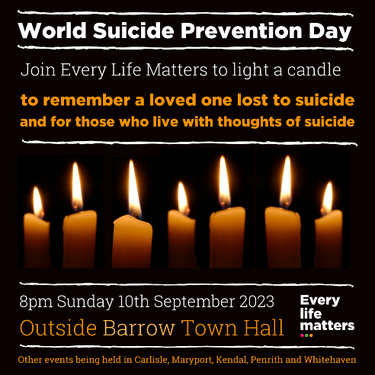 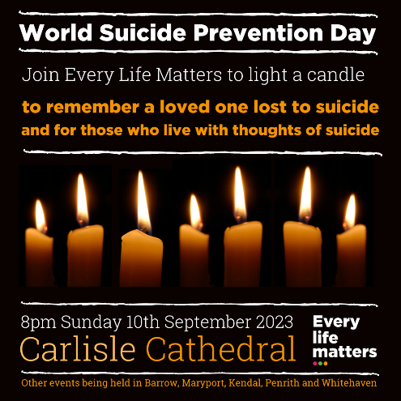 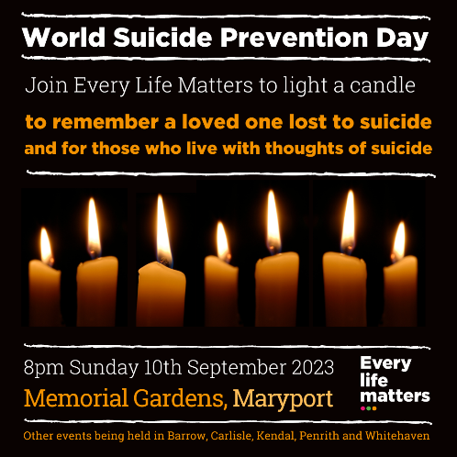

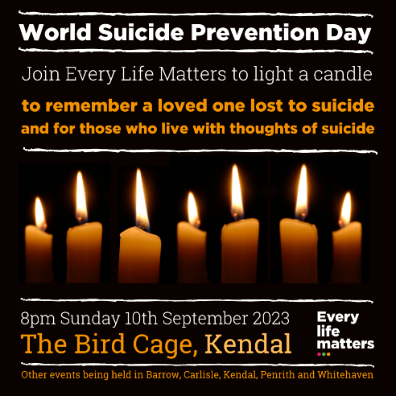 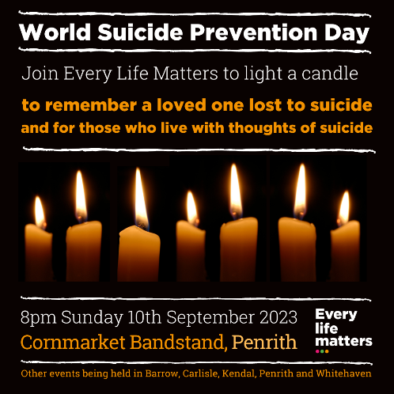 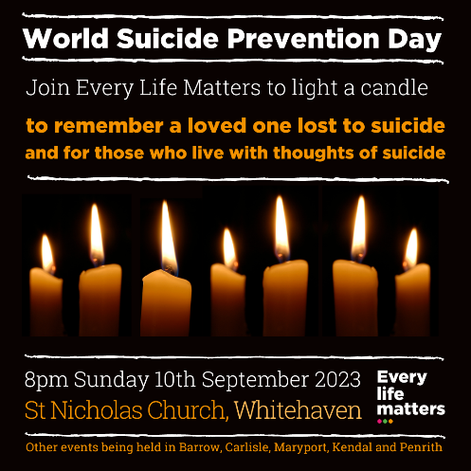

**Locations**

Barrow Town Hall, Carlisle Cathedral, The Bird Cage, Kendal, Memorial Gardens, Maryport, Cornmarket Bandstand, Penrith and St Nicholas Church, Whitehaven

**Facebook:**

Join Every Life Matters at [ADD LOCATION] on Sunday 10th September for World Suicide Prevention Day.

Events are taking place across the county and all are welcome to join and light a candle at 8 pm in memory of those lost to suicide and for those who live with thoughts of suicide.

To find out more about the event visit [www.every-life-matters.org.uk/wspd](http://www.every-life-matters.org.uk/wspd)

#WSPD

**Instagram:**

Join Every Life Matters at [ADD LOCATION] on Sunday 10th September for World Suicide Prevention Day.

Events are taking place across the county and all are welcome to join and light a candle at 8 pm in memory of those lost to suicide and for those who live with thoughts of suicide.

#WSPD

**Twitter:**

Join Every Life Matters at [ADD LOCATION] on Sun 10th Sept for #WSPD. Events are taking place across the county to come together & light a candle at 8 pm in memory of those lost to suicide & for those who live with thoughts of suicide.

Find out more [www.every-life-matters.org.uk/wspd](http://www.every-life-matters.org.uk/wspd)

**5. Training opportunities**

**In-house training**

Suicide Prevention training gives people the knowledge, skills and confidence to recognise and engage with someone experiencing thoughts of suicide, to start the conversation and to guide them towards the help they need. We can offer a range of training to suit your organisation, below are the two most common in-house training we provide around the county.

|  |  |
| --- | --- |
| https://www.every-life-matters.org.uk/wp-content/uploads/2021/05/S.-Awareness-alt.png | ****Suicide Awareness**** Our one hour bitesize FREE awareness session is aimed at **anyone in the community** who wants to learn more about the myths and facts surrounding suicide, understand when someone might be at risk, how to talk directly and comfortably about suicide, and what we can all do to offer practical support. |
| https://www.every-life-matters.org.uk/wp-content/uploads/2021/05/Suicide-Alertness-OB.png | ****Suicide Alertness**** This three hour FREE interactive training session is aimed at **anyone in a helping role** who wants to understand more about the context of suicide, identify when someone may be at risk, how to ask directly about suicide, and what we can do to support someone and guide them to the help they need. |

**Orange Button Community**

The Orange Button Community Scheme is a way of identifying people that have undertaken suicide prevention training. That they have the confidence to talk to others about suicide. It is a way of showing others in your community who are having thoughts of suicide, or are worried about somebody else, that you are: Comfortable to say/hear the word suicide. Can listen without judgement. Can inform people where to find help and support.

Participants on Suicide Alertness, MHFA and ASIST qualify to become Orange Button holders.

**Open training**

Throughout the year we offer open training for anyone who lives or works in Cumbria to attend for free. These occur both online and in-person around the county.

You can find out about training on offer and book a free space by visiting:

<https://www.eventbrite.co.uk/o/every-life-matters-19933502566> or contacting [training@every-life-matters.org.uk](mailto:training@every-life-matters.org.uk).

**6. Suicide in Cumbria**

**Suicide is everyone’s business.**

On average we lose one person every 6 days to death by suicide in Cumbria. This is more than double the amount of people who die on our counties roads.

Cumbria’s suicide rates remain consistently higher than the national average, and a disproportionate amount of these deaths are also focused on the West cost of Cumbria.

One I five Cumbrian residents will have thoughts of suicide, and one in fifteen will attempt suicide, at some point in their life.

No one should have to deal with suicidal thoughts alone.

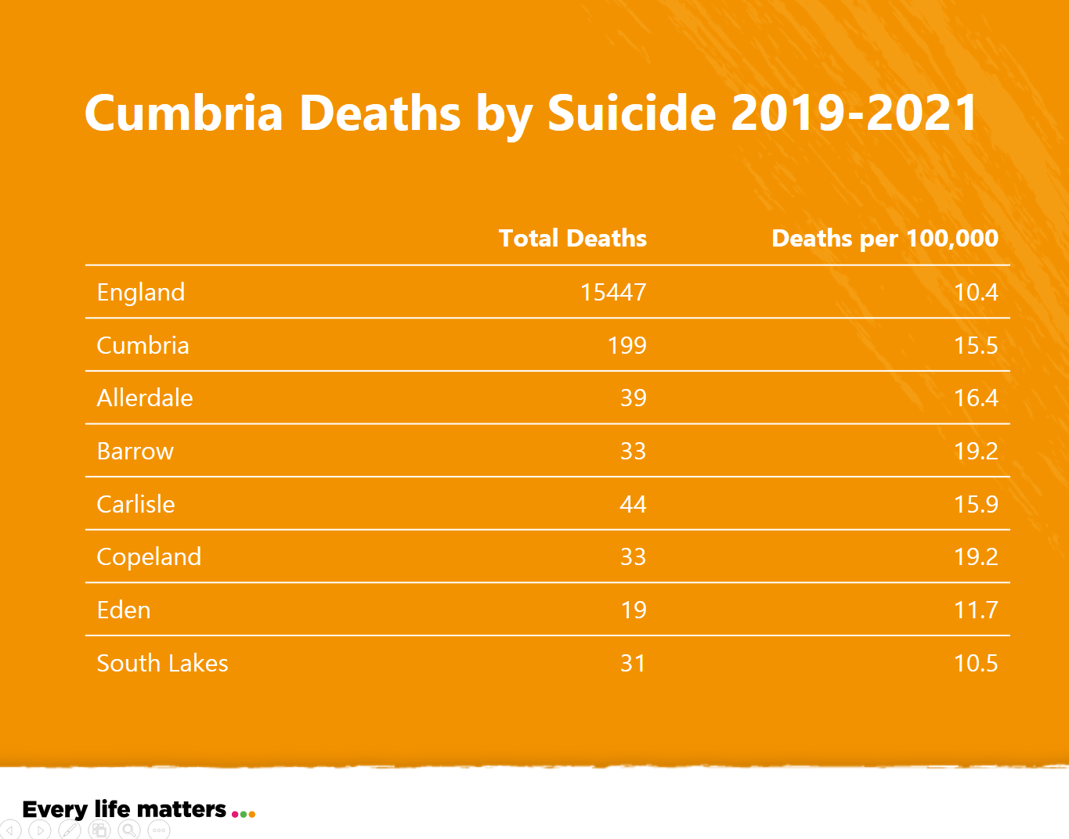

**More Context- Cumbrian Graphics**

Below you will find more context about suicide in Cumbria- these graphics can be used in social media content to build awareness.

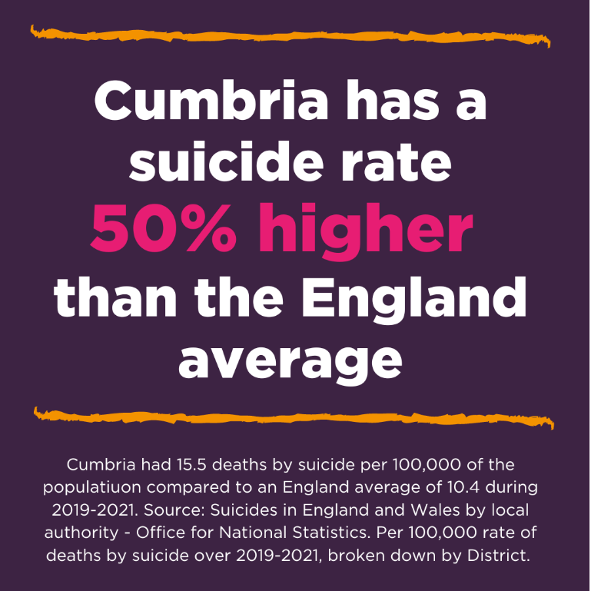

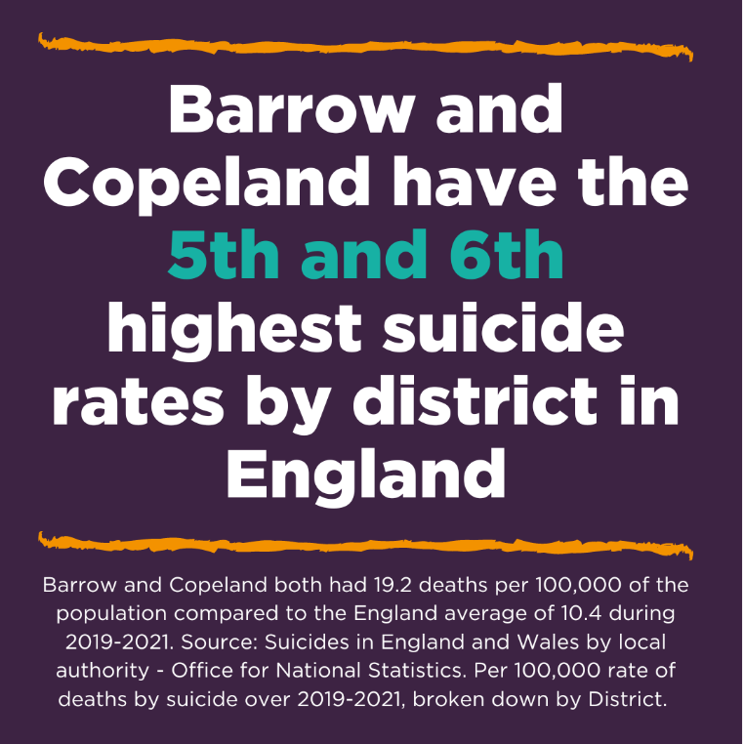

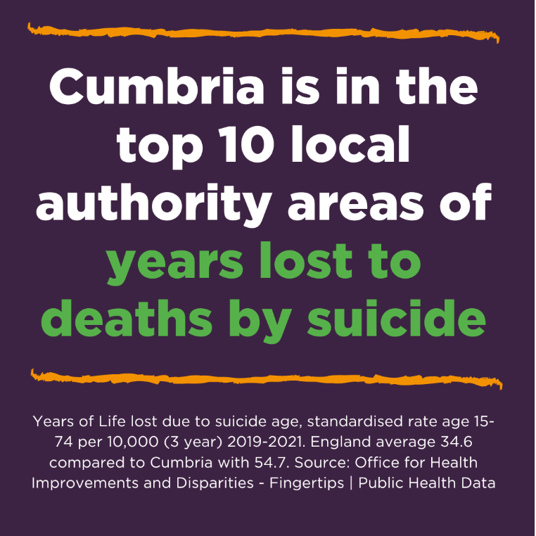

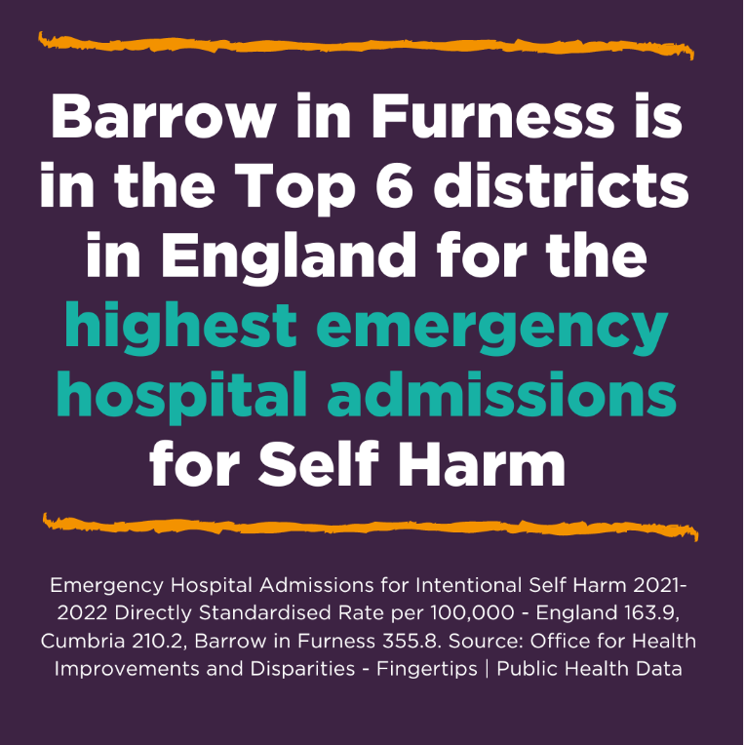

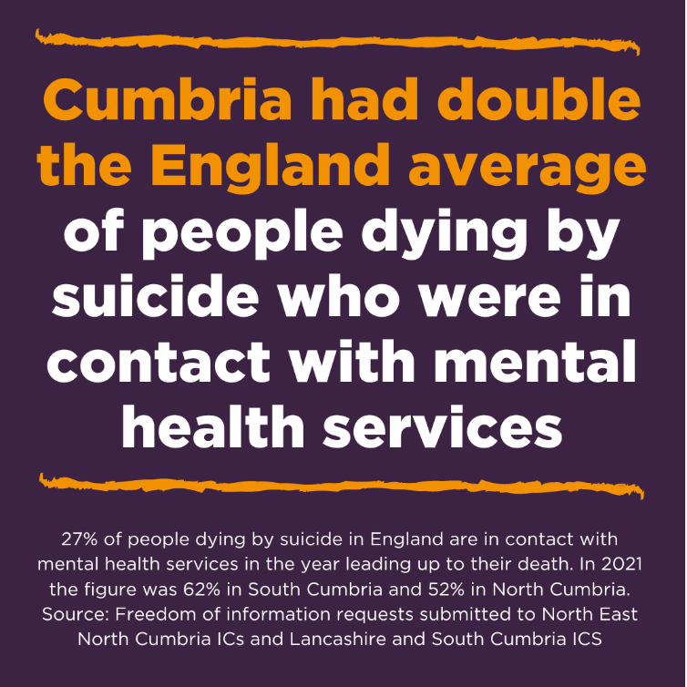

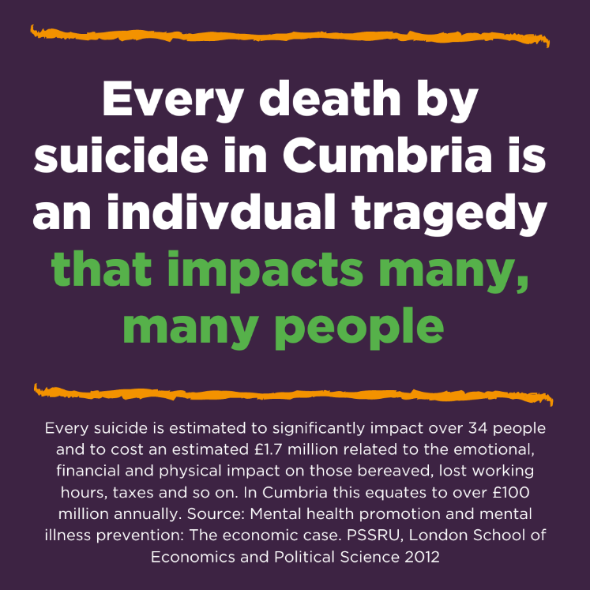

**7. About Every Life Matters**

**Working towards a zero suicide Cumbria, because Every Life Matters**

Every Life Matters was formed in 2019 by a group of people who wanted to take a long term and concerted approach to reducing deaths by suicide in Cumbria. This included people bereaved by suicide, or who had experienced thoughts of suicide themselves, and people who had been working in the suicide prevention field who knew too well that focus on suicide prevention waxed and waned too frequently.

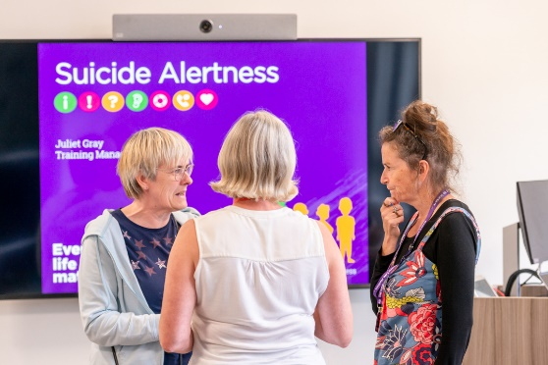

“Developing nationally recognized programmes and resources in Cumbria’s backyard.”

Our founders wanted suicide prevention to have the profile it deserved in a county that had some of the highest suicide rates in England. They wanted to take an innovative, well-funded and focused approach to suicide prevention, and suicide bereavement support, that was driven by a passion to make a difference, a willingness to be direct and in peoples face, one driven by evidence, and one delivered at scale. We strive to take a fresh, innovative and long-term approach to suicide prevention and suicide bereavement support in Cumbria, a County that has had suicide rates well above the national average for too many years.

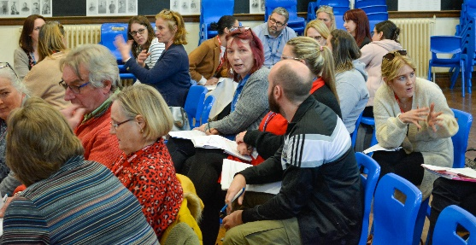

“Influencing the conversation about suicide”

Most people have been impacted in some way by suicide, and so many want to do something, to make a difference, but often don’t know where to start. We wanted Every Life Matters to sit alongside all of these individuals, communities and organizations, to offer training and resources, to start conversations, and to empower them to take positive action. It is this willingness of our local communities to engage with the suicide prevention agenda that has been the bedrock of our charities work, and considerable growth, since 2019.

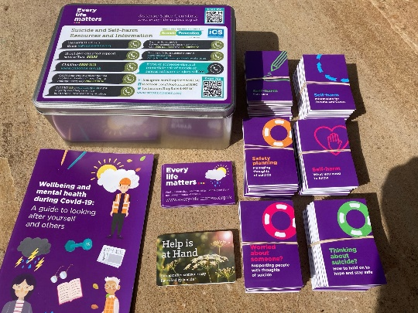

**GET IN TOUCH**

If you have any questions about the charity, fundraising or training please get in touch.

Phone: 07908 537541

Email: [info@every-life-matters.org.uk](mailto:info@every-life-matters.org.uk)

Follow us on social media

[but t](https://www.facebook.com/EveryLifeCumbria/) @EveryLifeMatters

[but i](https://www.instagram.com/everylifecumbria/) @everylifecumbria

[but tw](https://twitter.com/Every_Life_Cumb) @ Every_Life_Cumb

[www.every-life-matters.org.uk](http://www.every-life-matters.org.uk)