WSPD 2020 Reach Out Social Media

Right click on graphics to download to your desktop via “Save picture as” Option

Posts

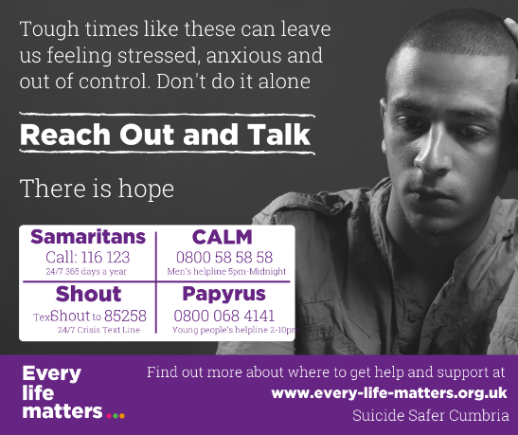

If you are struggling to cope, or are having thoughts of suicide, then reach out for help. There is support available, there is hope, and you are not alone.

A wide range of ways to get help and support are listed on our website https://www.every-life-matters.org.uk/get-help/ including talking therapies, self-help guides, peer support groups, online help and apps.

Share your feelings with a good friend, a relative or a work mate.

If it feels hard to find the words, speak to someone who is trained to listen, like the Samaritans on 116 123, or other telephone/text helplines. You can talk to them about whatever’s getting to you, in your own way, and they can also help you explore the range of help available.

Contact your GP or ring NHS 111. Be open about how you are feeling. Talk to a friend and plan what you want to say, and if possible get someone you live with to accompany you.

If you are having thoughts of suicide focus on what you need to do to keep yourself safe for now. Visit our https://www.every-life-matters.org.uk/thinking-about-suicide/ and https://www.every-life-matters.org.uk/safety-planning/ pages to learn more about what practical steps you can take to keep yourself safe.

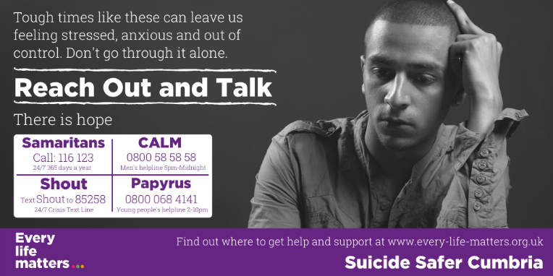

If you are struggling to cope, or are having thoughts of suicide, then reach out for help. There is support available, there is hope, and you are not alone. Find out more https://www.every-life-matters.org.uk/get-help/ #WSPD2020

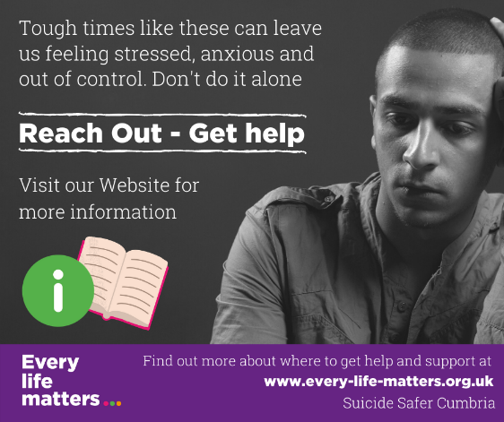

If you are struggling to cope, or are having thoughts of suicide, then reach out for help. There is support available, there is hope, and you are not alone.

A wide range of ways to get help and support are listed on our website https://www.every-life-matters.org.uk/get-help/ including talking therapies, self-help guides, peer support groups, online help and apps.

Share your feelings with a good friend, a relative or a work mate.

If it feels hard to find the words, speak to someone who is trained to listen, like the Samaritans on 116 123, or other telephone/text helplines. You can talk to them about whatever’s getting to you, in your own way, and they can also help you explore the range of help available.

Contact your GP or ring NHS 111. Be open about how you are feeling. Talk to a friend and plan what you want to say, and if possible get someone you live with to accompany you.

A wide range of ways to get help and support are listed on our website https://www.every-life-matters.org.uk/get-help/ including talking therapies, self-help guides, peer support groups, online help and apps.

If you are having thoughts of suicide focus on what you need to do to keep yourself safe for now. Visit our https://www.every-life-matters.org.uk/thinking-about-suicide/ and https://www.every-life-matters.org.uk/safety-planning/ pages to learn more about what practical steps you can take to keep yourself safe.

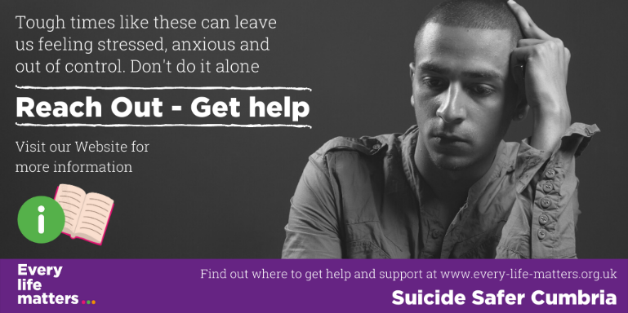

If you are struggling to cope, or are having thoughts of suicide, then reach out for help. There is support available, there is hope, and you are not alone. Find out more https://www.every-life-matters.org.uk/get-help/ #WSPD2020

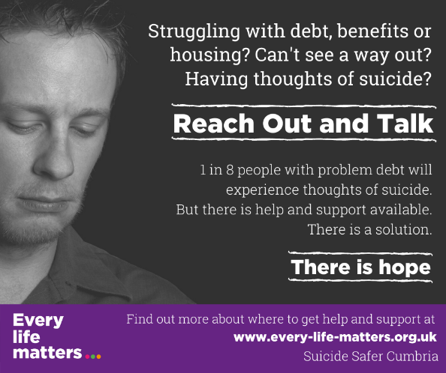

Struggling with money, benefits and housing problems is really tough, and for some it can lead to thoughts of suicide. But suicide is a permanent solution to a temporary problem. There is help and support available. There will be a way forward. There is hope. Find out more https://www.every-life-matters.org.uk/get-help/

Share your feelings with a good friend, a relative or a work mate.

If it feels hard to find the words, speak to someone who is trained to listen, like the Samaritans on 116 123, or other telephone/text helplines. You can talk to them about whatever’s getting to you, in your own way, and they can also help you explore the range of help available.

Contact your GP or ring NHS 111. Be open about how you are feeling. Talk to a friend and plan what you want to say, and if possible get someone you live with to accompany you.

If you are having thoughts of suicide focus on what you need to do to keep yourself safe for now. Visit our https://www.every-life-matters.org.uk/thinking-about-suicide/ and https://www.every-life-matters.org.uk/safety-planning/ pages to learn more about what practical steps you can take to keep yourself safe.

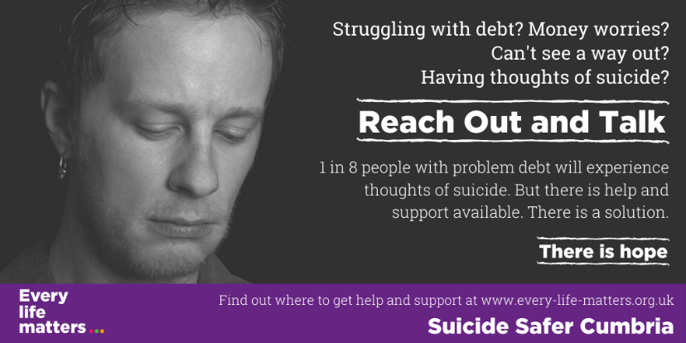

Struggling with money, benefits and housing problems is really tough, and for some it can lead to thoughts of suicide. But suicide is a permanent solution to a temporary problem. There is help and support available. There will be a way forward. There is hope. Find out more https://www.every-life-matters.org.uk/get-help/ #WSPD2020

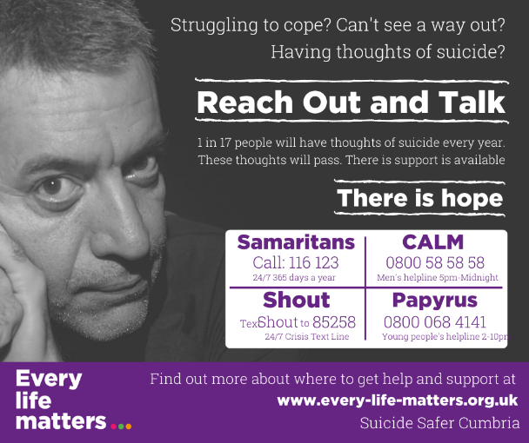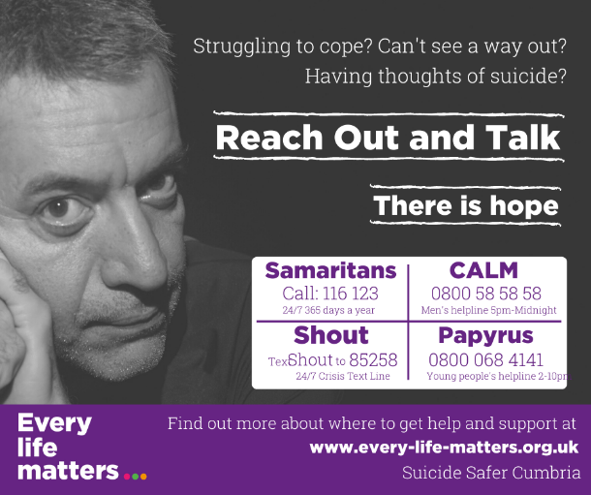

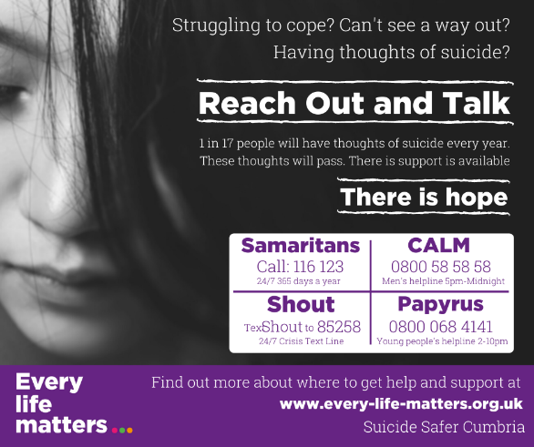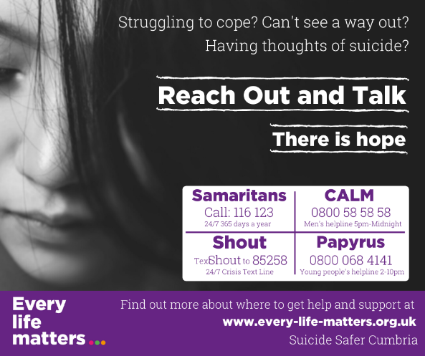

If you are struggling to cope, or are having thoughts of suicide, then reach out for help. There is support available, there is hope, and you are not alone.

A wide range of ways to get help and support are listed on our website https://www.every-life-matters.org.uk/get-help/ including talking therapies, self-help guides, peer support groups, online help and apps.

Share your feelings with a good friend, a relative or a work mate.

If it feels hard to find the words, speak to someone who is trained to listen, like the Samaritans on 116 123, or other telephone/text helplines. You can talk to them about whatever’s getting to you, in your own way, and they can also help you explore the range of help available.

Contact your GP or ring NHS 111. Be open about how you are feeling. Talk to a friend and plan what you want to say, and if possible get someone you live with to accompany you.

If you are having thoughts of suicide focus on what you need to do to keep yourself safe for now. Visit our https://www.every-life-matters.org.uk/thinking-about-suicide/ and https://www.every-life-matters.org.uk/safety-planning/ pages to learn more about what practical steps you can take to keep yourself safe.

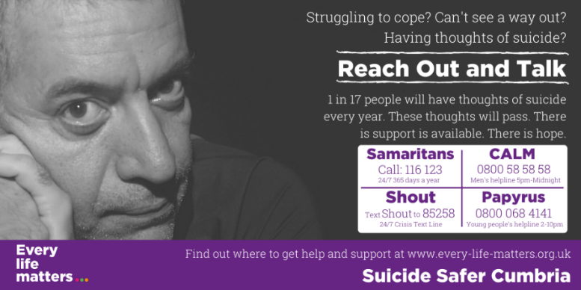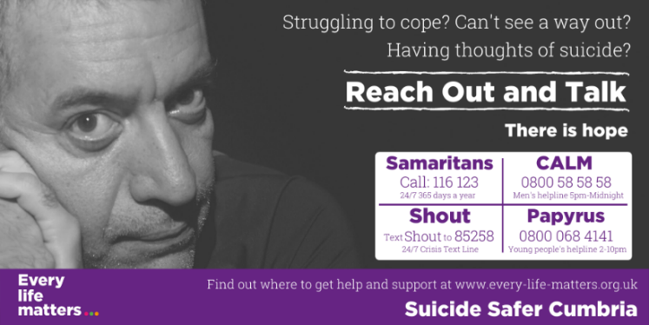

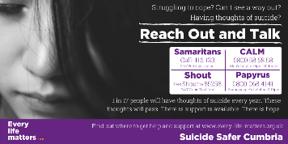

If you are struggling to cope, or are having thoughts of suicide, then reach out for help. There is support available, there is hope, and you are not alone. Find out more https://www.every-life-matters.org.uk/get-help/ #WSPD2020

3. Generic Posts/Suicide Facts

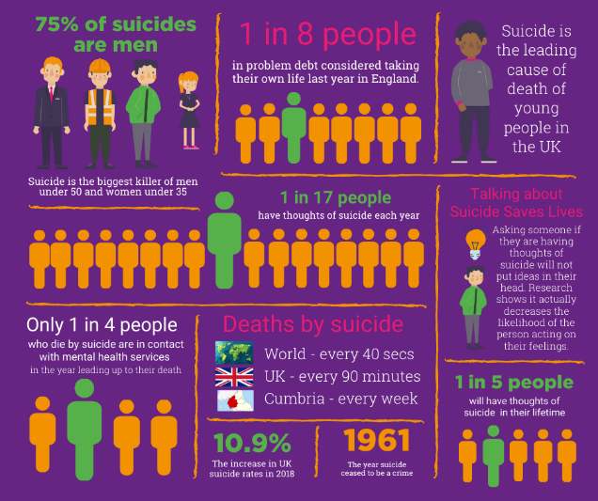

4. WSPD Specific

