WSPD 2020 Helping Others Social Media

Right click on graphics to download to your desktop via “Save picture as” Option

Posts

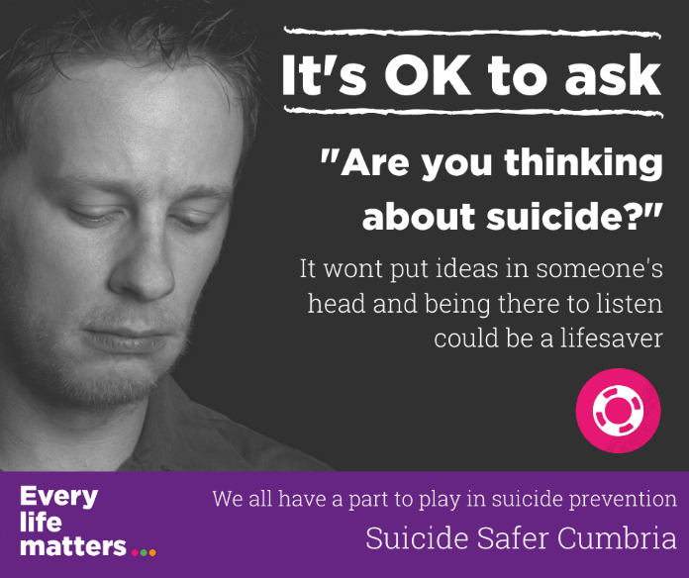

Talking about suicide openly and directly doesn’t hurt. It doesn’t increase the risk of it happening or put ideas in people’s heads. That’s a myth. The real risk is not mentioning it at all. Trust your gut instincts. If you are worried someone is having thoughts of suicide, ASK them. And Ask directly.

Clear questions receive clear answers like ‘are you thinking about suicide?’ It reduces uncertainty, identifies you as a safe and supportive person, and for the individual talking about suicidal thoughts can be a great relief.

There are often warning signs that someone is having thoughts of suicide. What someone is saying, how they are behaving, and what is happening in their lives. Visit https://www.every-life-matters.org.uk/woried-about-someone/ today to find out what they are, and what all of us can do to support someone with thoughts of suicide”

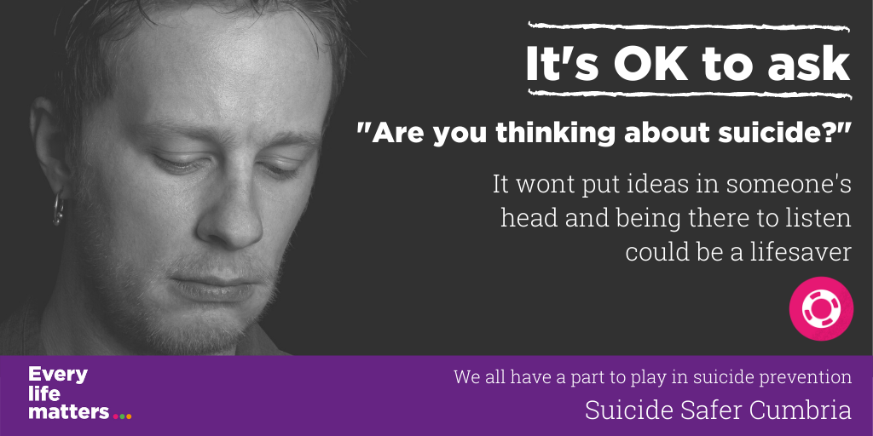

Talking about suicide openly and directly doesn’t hurt. It doesn’t increase the risk of it happening or put ideas in people’s heads. That’s a myth. The real risk is not mentioning it at all. Trust your gut instincts. If you are worried someone is having thoughts of suicide, ASK them. And Ask directly. “Are you thinking about suicide?” https://www.every-life-matters.org.uk/woried-about-someone/ #WSPD2020

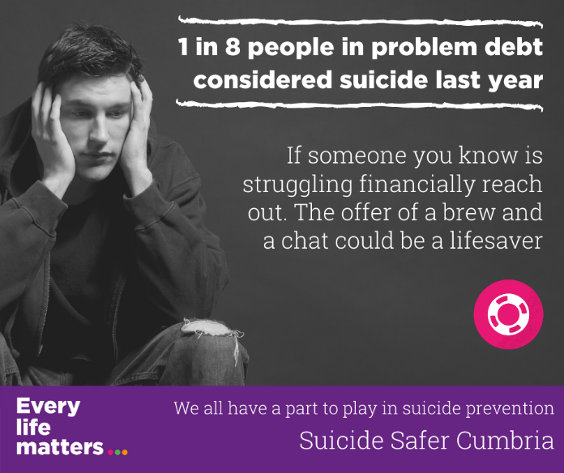

1 in 8 people in problem debt considered taking their own life last year. If you know someone struggling with debt, benefits or housing problems reach out to them. The smallest displays of kindness, like picking up the phone to check-in on someone, and the conversation that follows, could make the difference. You don’t need to solve their problems and knowing someone cares could be enough to get them through.

Encourage them to reach out for support. There are lots of organisations who can help people having financial, benefits or housing difficulties. Visit https://www.every-life-matters.org.uk/get-help/ for more information.

You can help them by supporting them to attend meetings, helping devise an action plan to move forward and building a circle of support while they get through their difficulties.

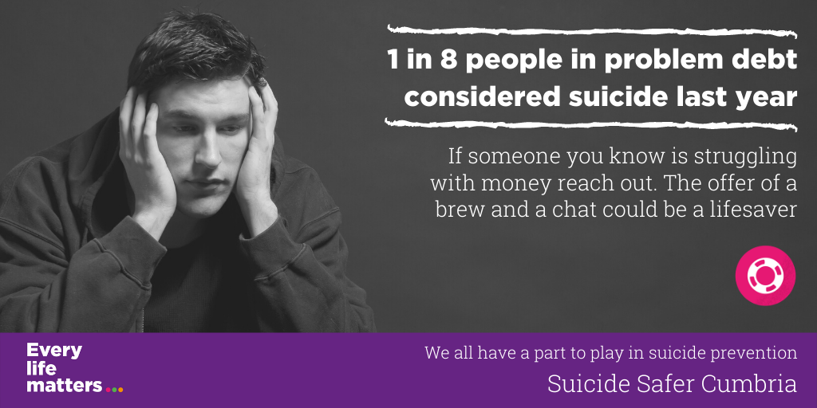

1 in 8 people in problem debt considered taking their own life last year. If you know someone struggling with debt, benefits or housing problems reach out to them. The smallest displays of kindness could make the difference. Encourage them to reach out. There are lots of organisations who can help. Visit https://www.every-life-matters.org.uk/get-help/ #WSPD2020

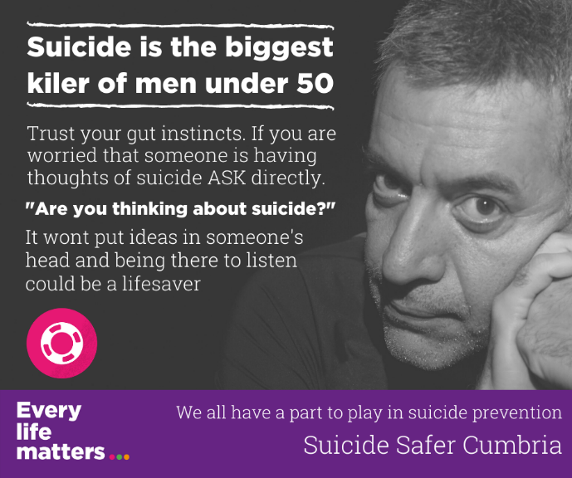

Talking about suicide openly and directly doesn’t hurt. It doesn’t increase the risk of it happening or put ideas in people’s heads. That’s a myth. The real risk is not mentioning it at all. Trust your gut instincts. If you at all worried someone is having thoughts of suicide, ASK them. And Ask directly.

Clear questions receive clear answers like ‘are you thinking about suicide?’ It reduces uncertainty, identifies you as a safe and supportive person, and for the individual talking about suicidal thoughts can be a great relief.

There are often warning signs that someone is having thoughts of suicide. What someone is saying, how they are behaving, and what is happening in their lives. Visit https://www.every-life-matters.org.uk/woried-about-someone/ today to find out what they are, and what all of us can do to support someone with thoughts of suicide”

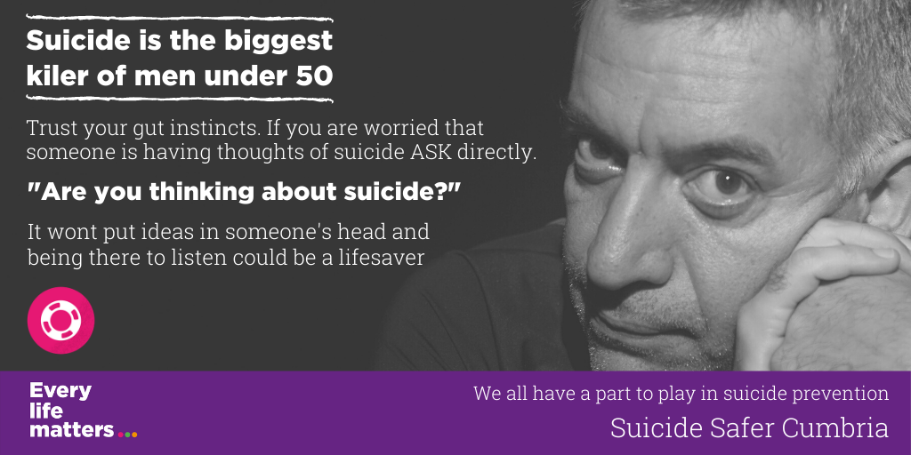

Talking about suicide openly and directly doesn’t hurt. It doesn’t increase the risk of it happening or put ideas in people’s heads. That’s a myth. The real risk is not mentioning it at all. Trust your gut instincts. If you at all worried someone is having thoughts of suicide, ASK them. And Ask directly. “Are you thinking about suicide?” https://www.every-life-matters.org.uk/woried-about-someone/ #WSPD2020

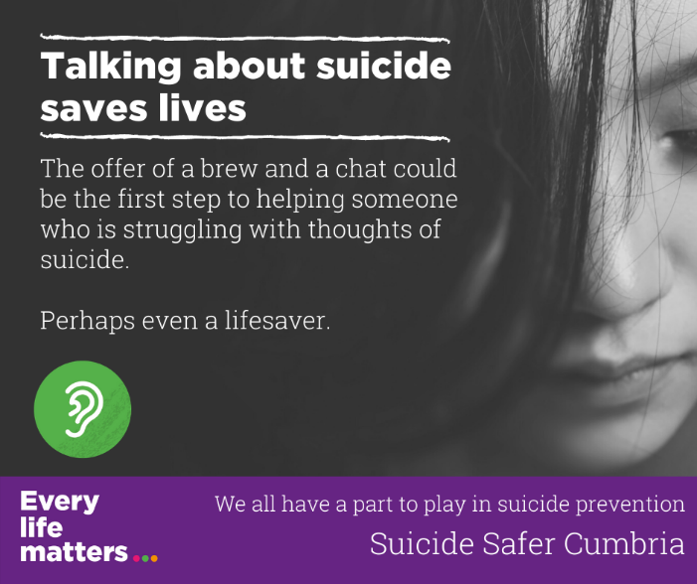

We can all play a role in helping people whose mental health is at risk. The smallest displays of kindness, like picking up the phone to check-in on someone, and the conversation that follows, could make the difference. You don’t need to solve their problems and knowing someone cares could be enough to get them through. And perhaps even save a life.

If you’re worried that someone may be feeling suicidal it can be really hard to know what to say to them, or how to help. But thinking about suicide does not make it inevitable that someone is going to take their own life, and all of us have the ability to support someone who is experiencing thoughts of suicide, and to save lives.

There are often warning signs that someone is having thoughts of suicide. What someone is saying, how they are behaving, and what is happening in their lives. Visit https://www.every-life-matters.org.uk/woried-about-someone/ today to find out what they are, and what all of us can do to support someone with thoughts of suicide.

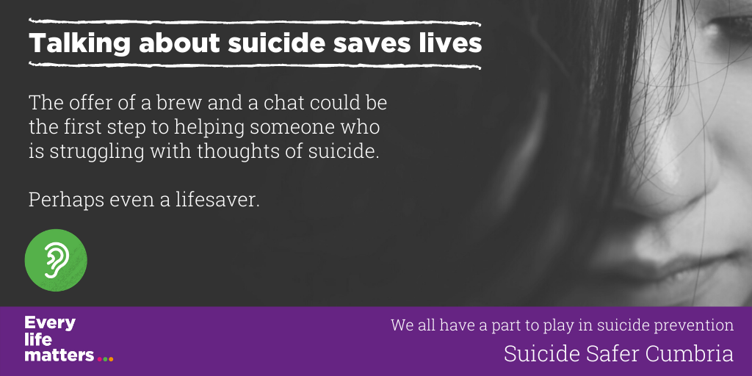

We can all play a role in helping people whose mental health is at risk. The smallest displays of kindness, like picking up the phone to check-in on someone, and the conversation that follows, could make the difference. You don’t need to solve their problems and knowing someone cares could be enough to get them through. And perhaps even save a life https://www.every-life-matters.org.uk/helping-others/ #WSPD2020

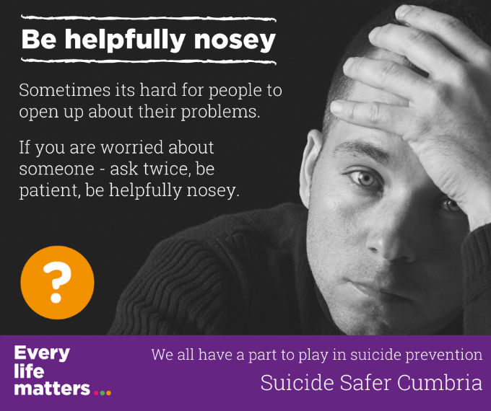

It’s more important than ever to find ways to keep contact, to check-in, and to offer support to those around us. But remember many people struggle to reach out for support and sometimes we might need to ask, and ask again, “How are you?”. If you are worried about someone don’t be content with an “I’m alright mate”.

Be helpfully nosey, and be patient. Let them know why are concerned, and that you are there for them.
To find out more about helping others visit https://www.every-life-matters.org.uk/helping-others/

We can also help others by making them aware of the range of help available to support their mental health or other problems in their life such as debt, employment, relationship problems and so on. Visit https://www.every-life-matters.org.uk/get-help/ to find out more

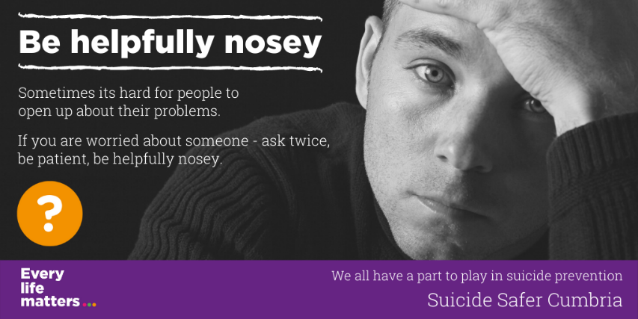

Many people struggle to reach out for support and sometimes we might need to ask, and ask again, “How are you?”. If you are worried about someone don’t be content with an “I’m alright mate”. Be helpfully nosey, and be patient. Let them know why are concerned, and that you are there for them.
For more ideas https://www.every-life-matters.org.uk/helping-others/ #WSPD2020

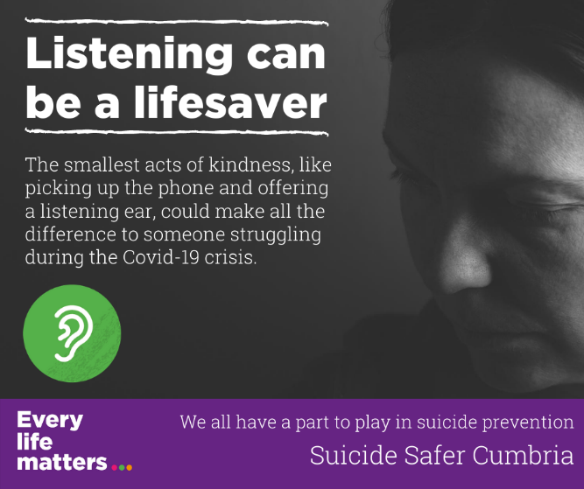

One of the best things you can do for a person who is struggling with their mental health or having thoughts of suicide is to simply encourage them to talk about their feelings. And to make sure you really listen to what they’re saying. Don’t ever be put off approaching someone because you don’t know what to say.

Talking about our fears and feelings can be difficult, even to those closest to us. Be patient and give re-assurance. Have at a look at our key listening tips at https://www.every-life-matters.org.uk/helping-others/

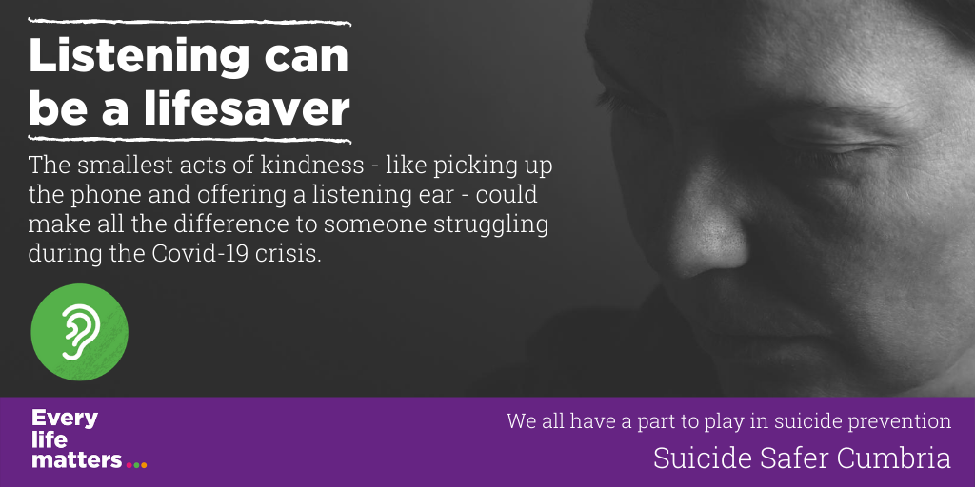

One of the best things you can do for a person who is struggling with their mental health, or having thoughts of suicide, is to simply encourage them to talk about their feelings. And to make sure you really listen to what they’re saying. Don’t ever be put off approaching someone because you don’t know what to say. Have at a look at our key listening tips at https://www.every-life-matters.org.uk/helping-others/ #WSPD2020

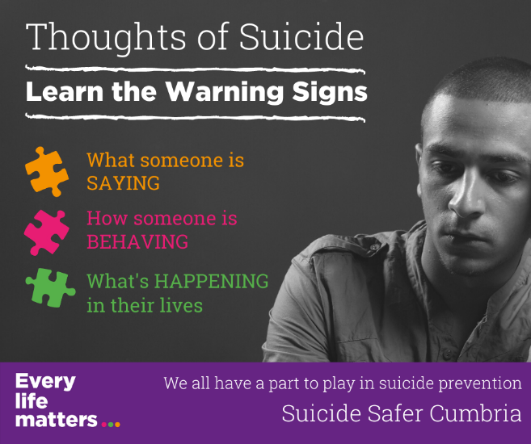

Many people contemplating suicide do not let their friends or family know directly how they are feeling – but often there are warning signs that someone may be feeling suicidal – signs we can be alert to. And recognising these signs could be a lifesaver. Find out more about signs of risk, and how to support some with thoughts of suicide at https://www.every-life-matters.org.uk/woried-about-someone/

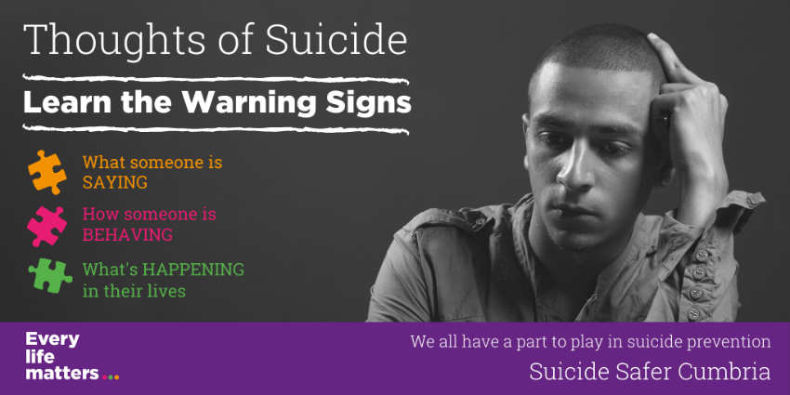

Many people contemplating suicide do not let their friends or family know directly how they are feeling – but often there are warning signs that someone may be feeling suicidal – signs we can be alert to. And recognising these signs could be a lifesaver https://www.every-life-matters.org.uk/woried-about-someone/ #WSPD2020

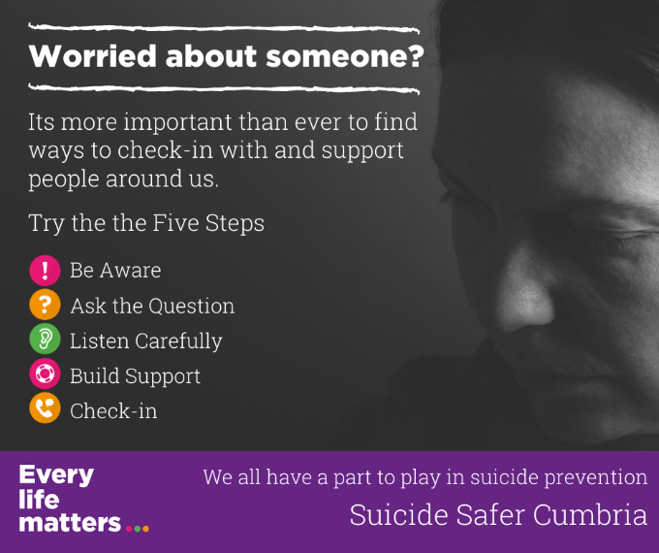

We can all play a role in helping people whose mental health at risk. Showing you care, offering support and a listening ear can all go a long way. You don’t need to solve their problems and knowing someone cares could be enough to get them through https://www.every-life-matters.org.uk/helping-others/

This is a challenging time. Show interest in the people around you. Show you care through asking questions about how they are thinking and feeling. And don’t be afraid to ask twice if you are worried. Check in, and continue to check in.

Be Aware
Watch for the warning signs that someone might be struggling. This is more challenging during right now, and we may need to be more pro-active about checking in with others by phone and online.

Ask
Trust your instincts and ask the person directly how they are doing. If you feel they may be struggling let them know that you are worried about them and that you care. But remember many people struggle to reach out for support and sometimes we might need to ask, and ask again, “How are you?”. If you are worried about someone don’t be content with an “I’m alright mate”.

Listen
Give them time and space to talk and be helpfully nosey. Have a look at our listening tips.

Build Support
Explore what help they might need. Build a circle of support through family and friends. Have a look together at what support is available at https://www.every-life-matters.org.uk/get-help/. Set goals about what they can do next. And if it’s useful attend appointments with them or help them plan what they want to say.

Check-in
Keep Checking in and letting the person know you are there for them. Knowing someone cares can make all the difference.

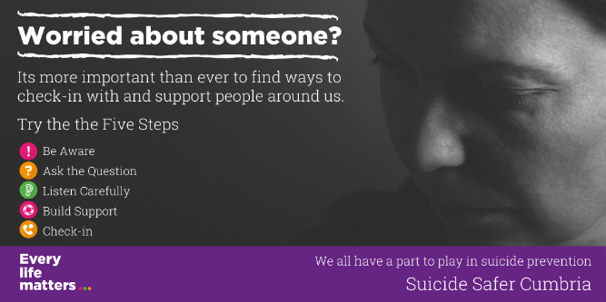

We can all play a role in helping people whose mental health at risk. Showing you care, offering support and a listening ear can all go a long way. You don’t need to solve their problems and knowing someone cares could be enough to get them through https://www.every-life-matters.org.uk/helping-others/ #WSPD2020
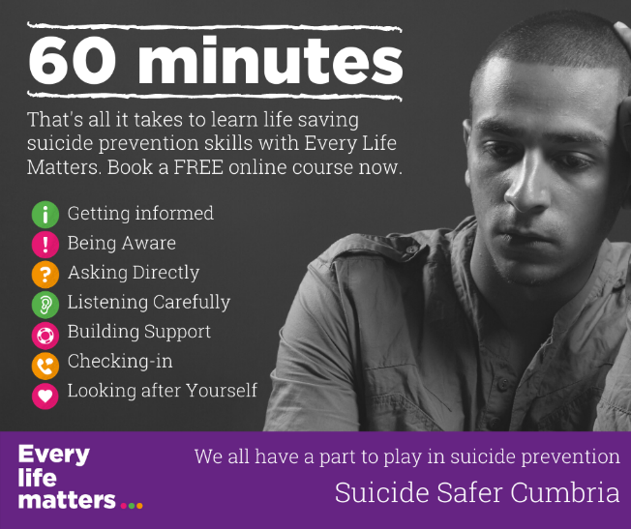

Suicide is everyone’s business. Our 60 minute online courses are aimed at anyone in Cumbria who wants to learn more about suicide, be aware when someone might be having thoughts of suicide, and what we can all do to offer practical support. Book a place today at https://www.every-life-matters.org.uk/training/

"Clear, informative, and it ‘humanised’ an issue that is often pushed under the carpet or avoided – really well done” That’s what one participant had to say about our hour-long suicide awareness workshop today.

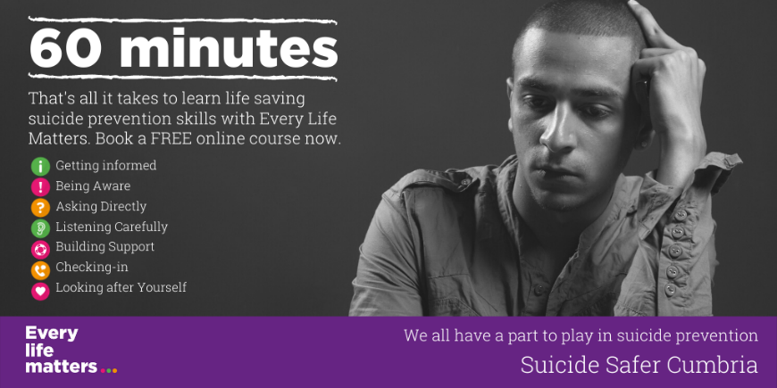

Suicide is everyone’s business. Our 60 minute online courses are aimed at anyone in Cumbria who wants to learn more about suicide, be aware when someone is at risk, and what we can all do to offer practical support. Book a place today at https://www.every-life-matters.org.uk/training/ #WSPD2020

3. Generic Posts/Suicide Facts

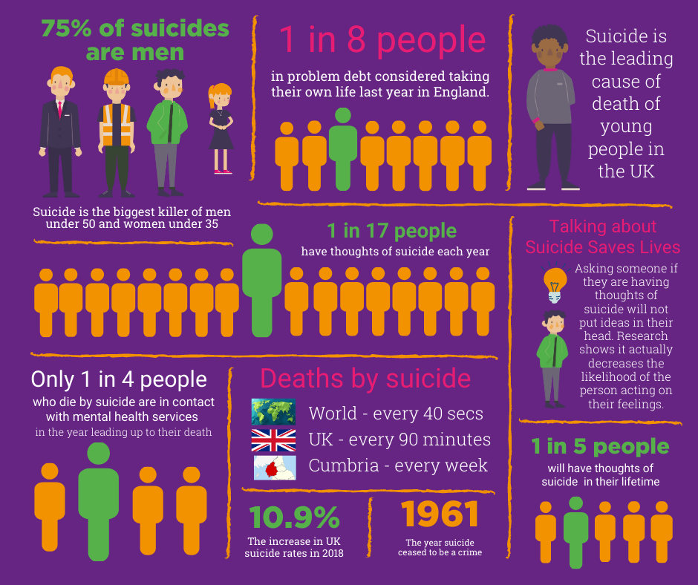

4. WSPD Specific

